1. MYSQL BASIC
2. CRUD
   1. CREATE
   2. READ
   3. UPDATE
   4. DELETE
3. DISTINCT
4. ORDER BY
5. LIMIT
6. LIKE
7. BASIC FUNCTION
8. LOGICAL OPERATOR
9. LESS & GREATER THAN
10. STRING FUNCTION
11. REVERSE FUNCTION
12. CHAR_LENGTH
13. DATE TIME DATA TYPES
14. FOREIGN KEY
15. SQL JOIN
    1. INNER JOIN
    2. LEFT JOIN
    3. RIGHT JOIN

------- : MYSQL BASIC : -------

**mysql> show databases;**

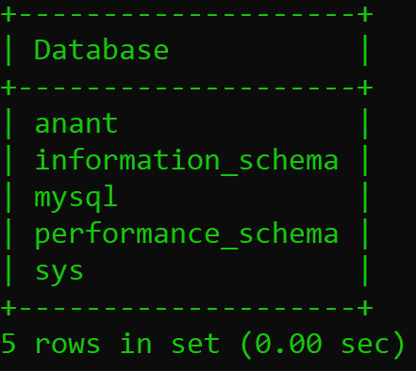

**mysql> drop database anant;**

Query OK, 0 rows affected (0.02 sec)

**mysql> create database anantdb;**

Query OK, 1 row affected (0.01 sec)

**mysql> show databases;**

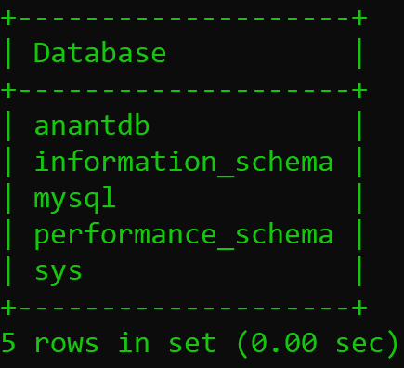

**mysql> use anantdb;**

Database changed

**mysql> create table details(id integer primary key,first_name varchar(20),name varchar(20),last_name varchar(20),proffession varchar(30),mobile_no integer(10),salary integer(10));**

Query OK, 0 rows affected, 2 warnings (0.02 sec)

**mysql> insert into details values(1,'soni','anant','rajeshkumar','web-developer',989658659,65000);**

Query OK, 1 row affected (0.01 sec)

**mysql> insert into details values(2,'rana','ashutosh','rameshkumar','app-developer',989658589,55000);**

Query OK, 1 row affected (0.01 sec)

**mysql> insert into details values(3,'patel','dhruv','sureshkumar','web-designer',989655589,45000);**

Query OK, 1 row affected (0.01 sec)

**mysql> insert into details values(4,'prajapati','kenil','dineshkumar','app-designer',989589589,58000);**

Query OK, 1 row affected (0.01 sec)

**mysql> insert into details values(5,'patel','kanu','ramalal','software-engineer',989578589,98000);**

Query OK, 1 row affected (0.01 sec)

**mysql> show tables;**

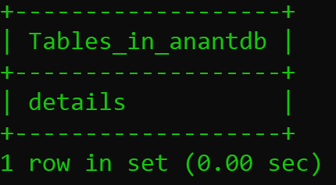

**mysql> desc details;**

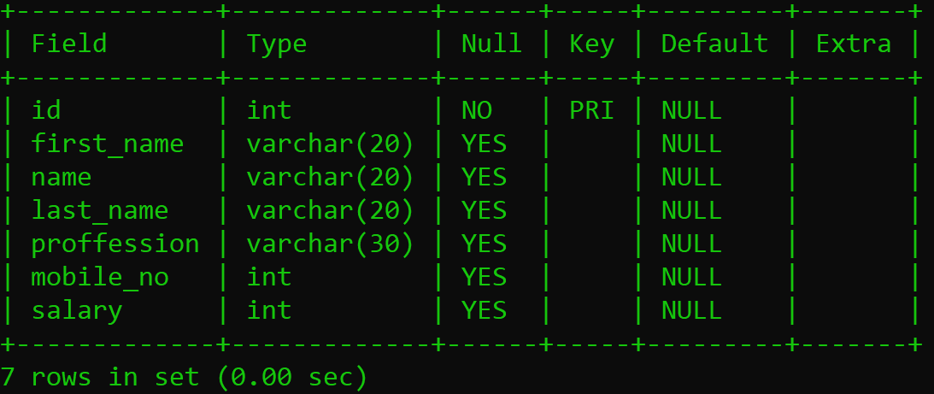

**mysql> select*from details;**

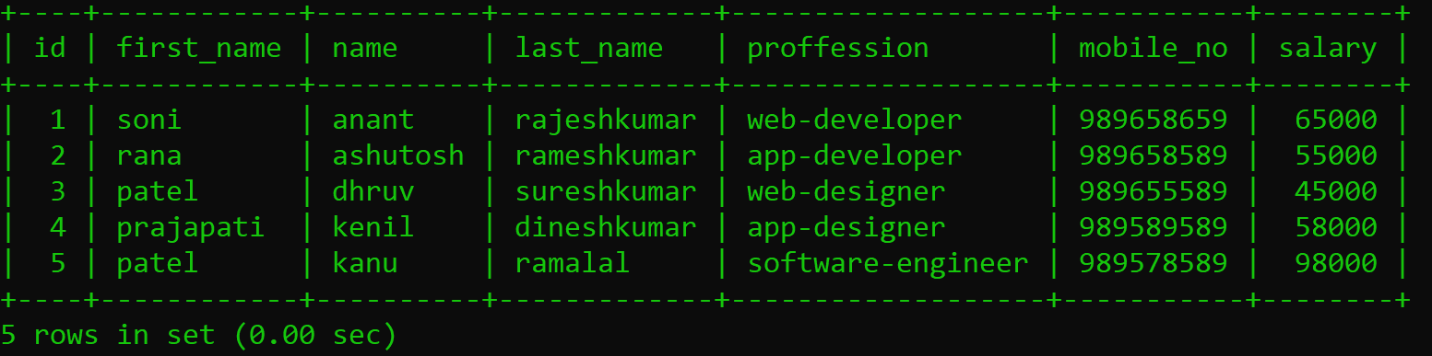

**mysql> alter table details add roll_no int(10);**

Query OK, 0 rows affected, 1 warning (0.03 sec)

Records: 0 Duplicates: 0 Warnings: 1

**mysql> select*from details;**

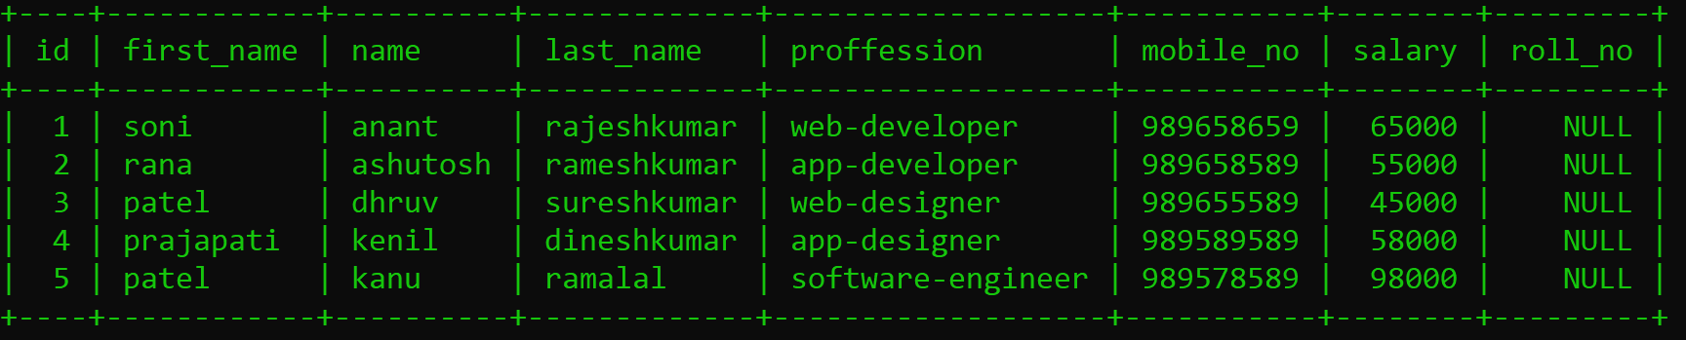

**mysql> alter table details drop column roll_no;**

Query OK, 0 rows affected (0.17 sec)

Records: 0 Duplicates: 0 Warnings: 0

**mysql> select*from details;**

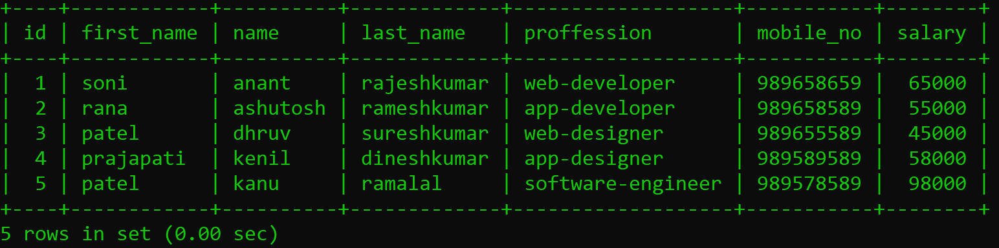

**mysql> drop database anantdb;**

Query OK, 1 row affected (0.02 sec)

**mysql> show databases;**

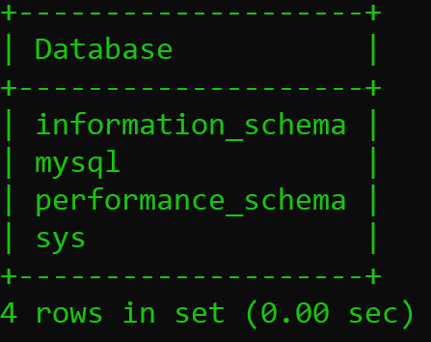

**mysql> create database student_details;**

Query OK, 1 row affected (0.01 sec)

**mysql> show databases;**

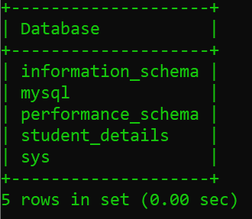

**mysql> use student_details;**

Database changed

**------- :** **CRUD : CREATE, READ, UPDATE, DELETE : -------**

**------- :** **CREATE : -------**

**mysql> create table students(ID int not null auto_increment,FNAME varchar(55),LNAME varchar(55),AGE int,primary key(ID));**

**mysql> insert into students(FNAME,LNAME,AGE)values('vinod','thapa',25);**

Query OK, 1 row affected (0.01 sec)

**mysql> insert into students(FNAME,LNAME**

**students(FNAME,LNAME,AGE)values('vinod','thapa',25);**

Query OK, 1 row affected (0.01 sec)

**mysql> insert into students(FNAME,LNAME,AGE)values('vinod','bahadur',25);**

Query OK, 1 row affected (0.01 sec)

**mysql> insert into students(FNAME,LNAME,AGE)values('naran','kc',28);**

Query OK, 1 row affected (0.01 sec)

**mysql> insert into students(FNAME,LNAME,AGE)values('thapa','technical',24);**

Query OK, 1 row affected (0.01 sec)

**mysql> insert into students(FNAME,LNAME,AGE)values('arjun','kc',26);**

Query OK, 1 row affected (0.01 sec)

**mysql> insert into students(FNAME,LNAME,AGE)values('binta','thapa',21);**

Query OK, 1 row affected (0.01 sec)

**mysql> insert into students(FNAME,LNAME,AGE)values('ramesh','thapa',22);**

Query OK, 1 row affected (0.01 sec)

**mysql> insert into students(FNAME,LNAME,AGE)values('amrit','thapa',23);**

Query OK, 1 row affected (0.01 sec)

**mysql> insert into students(FNAME,LNAME,AGE)values('ram','chettri',23);**

Query OK, 1 row affected (0.01 sec)

**mysql> insert into students(FNAME,LNAME,AGE)values('kanxi','thapa',25);**

Query OK, 1 row affected (0.01 sec)

**mysql> show tables;**

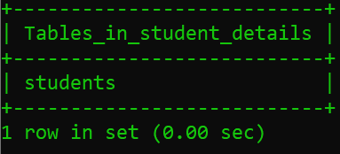

**mysql> desc students;**

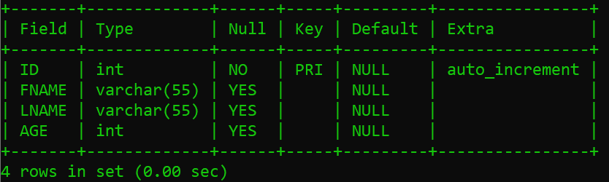

**mysql> select*from students;**

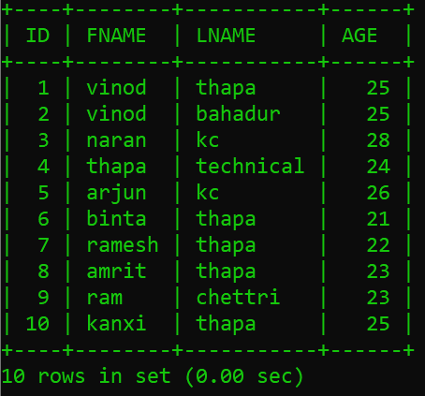

**------- :** **READ : -------**

**mysql> select*from students where age=25;**

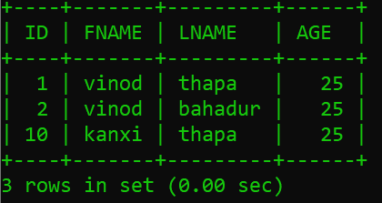

**mysql> select FNAME from students where age=25;**

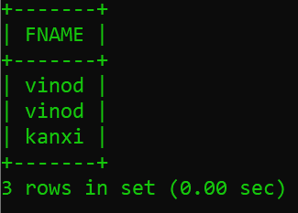

**mysql> select FNAME,LNAME from students where age=25;**

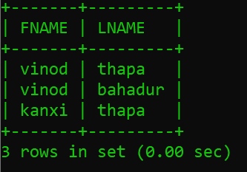

**------- :** **UPDATE : -------**

**mysql> update students set AGE=23 where FNAME='ramesh';**

Query OK, 1 row affected (0.00 sec)

Rows matched: 1 Changed: 1 Warnings: 0

**mysql> select*from students;**

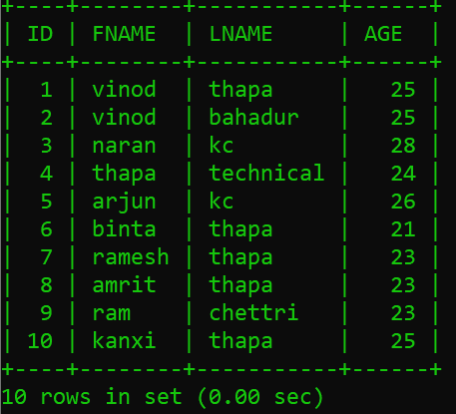

**mysql> update students set AGE=55 where ID=10;**

Query OK, 1 row affected (0.00 sec)

Rows matched: 1 Changed: 1 Warnings: 0

**mysql> select*from students;**

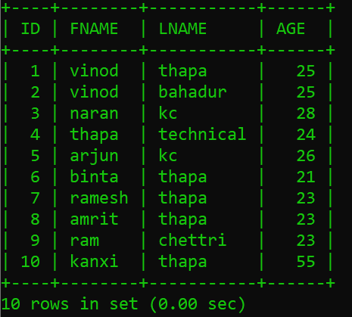

**------- :** **DELETE : -------**

**mysql> delete from students where FNAME='naran';**

Query OK, 1 row affected (0.01 sec)

**mysql> select*from students;**

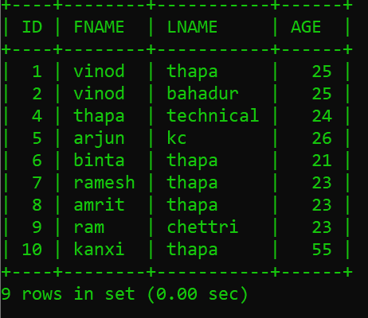

**mysql> delete from students where ID='7';**

Query OK, 1 row affected (0.01 sec)

**mysql> select*from students;**

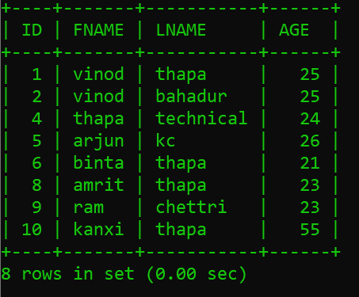

**mysql> insert into students values(7,'ramesh','thapa',23);**

Query OK, 1 row affected (0.01 sec)

**mysql> select*from students;**

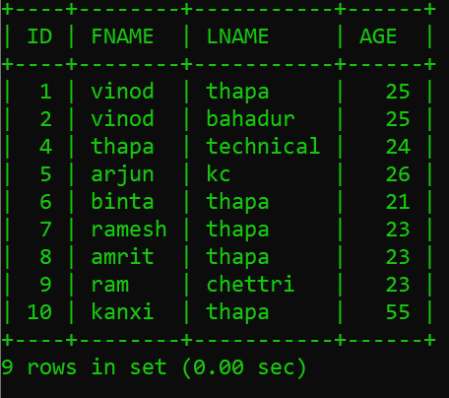

**------- :** **DISTINCT : -------**

**mysql> select FNAME from students;**

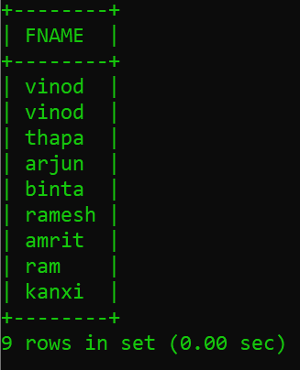

**mysql> select distinct FNAME from students;**

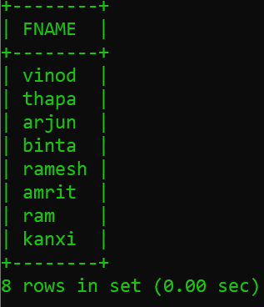

**mysql> select FNAME,AGE from students;**

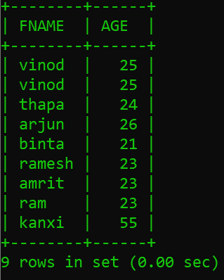

**mysql> select distinct AGE from students;**

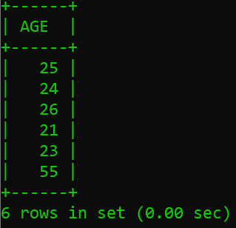

**mysql> select distinct FNAME,AGE from students;**

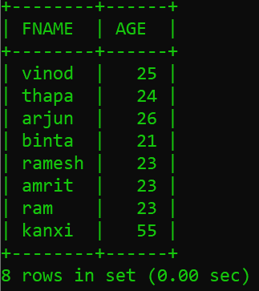

**------- :** **ORDER BY : -------**

**mysql> select age from students order by age;**

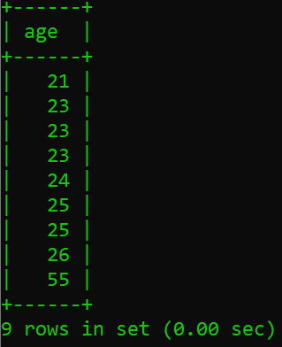

**mysql> select FNAME from students order by age;**

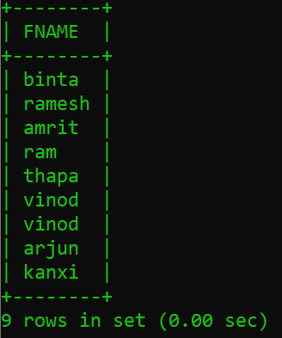

**mysql> select FNAME,LNAME,AGE from students order by AGE;**

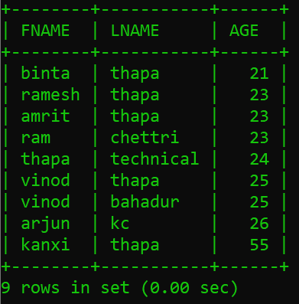

**------- :** **LIMIT : -------**

**mysql> select FNAME,LNAME,AGE from students order by AGE limit 5;**

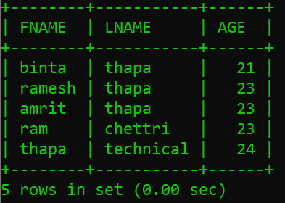

**------- :** **LIKE : -------**

**mysql> select FNAME from students where FNAME like'%in%';**

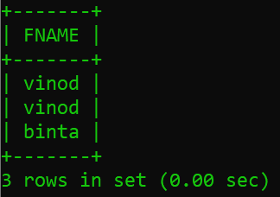

**mysql> select LNAME from students where FNAME like '%ha%';**

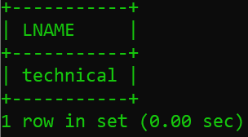

**mysql> select LNAME from students where LNAME like '%ha%';**

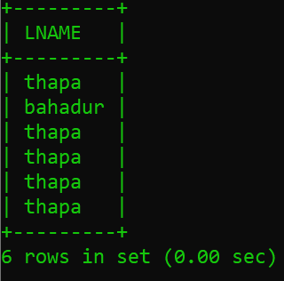

**------- :** **BASIC FUNCTION : -------**

**mysql> select max(age) from students;**

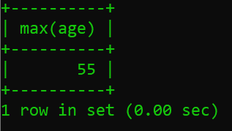

**mysql> select min(age) from students;**

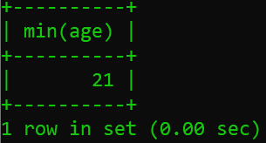

**mysql> select sum(age) from students;**

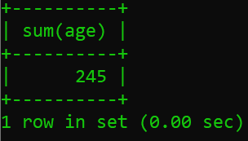

**mysql> select count(id) from students;**

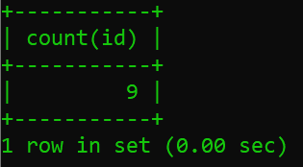

**mysql> select avg(age) from students;**

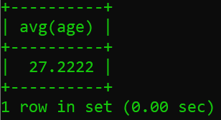

**------- :** **LOGICAL OPERATOR : -------**

**mysql> select * from students where AGE=25;**

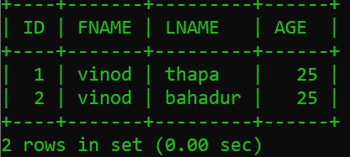

**mysql> select * from students where AGE!=25;**

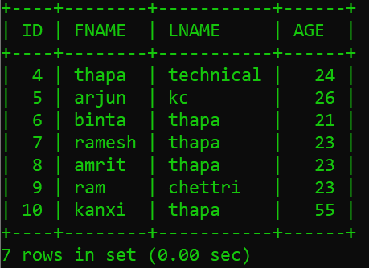

**mysql> select * from students where LNAME='thapa';**

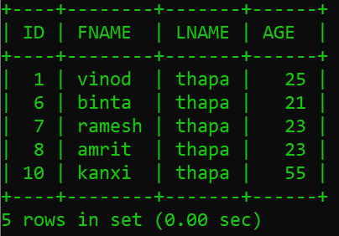

**mysql> select * from students where LNAME!='thapa';**

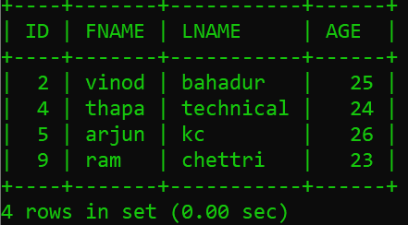

**------- :** **LESS & GREATER THAN : -------**

**mysql> select*from students where age>25;**

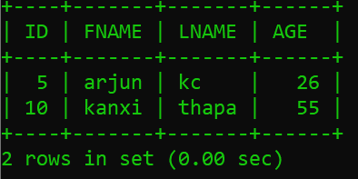

**mysql> select*from students where age>=25;**

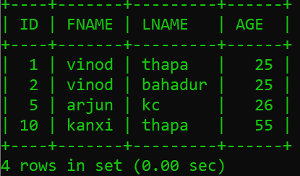

**mysql> select*from students where age<25;**

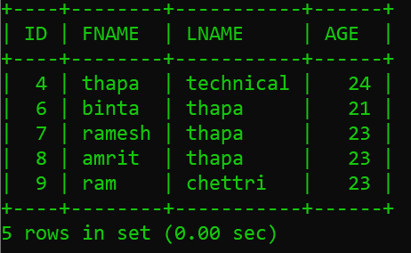

**mysql> select*from students where age<=25;**

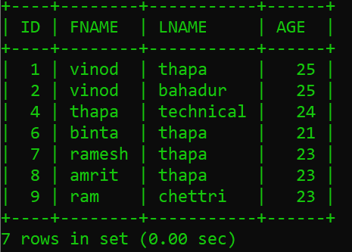

**mysql> select*from students where age=25;**

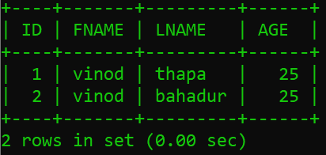

**mysql> select*from students where age not between 22 and 50;**

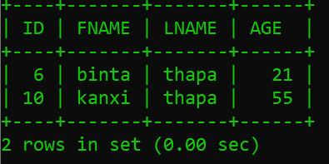

**mysql> select*from students where age between 21 and 24;**

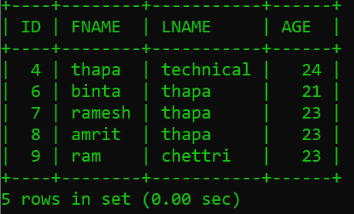

**mysql> select*from students where FNAME in('vinod','binita');**

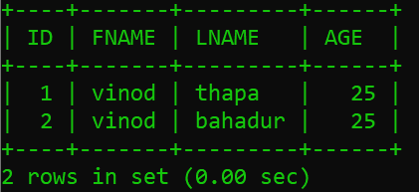

**mysql> select*from students where FNAME='vinod' or 'binita';**

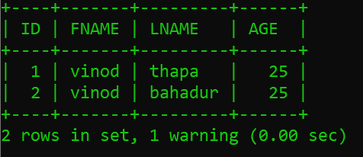

**------- :** **STRING FUNCTION : -------**

**mysql> select concat('vinod','thapa');**

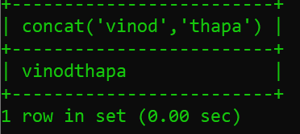

**mysql> select concat('anant','soni');**

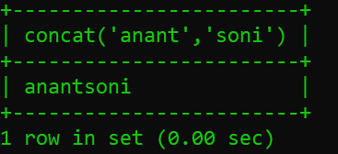

**mysql> select concat('vinod','','thapa');**

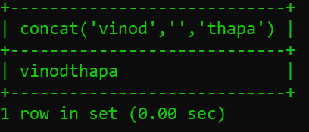

**mysql> select concat('anant',' ','soni');**

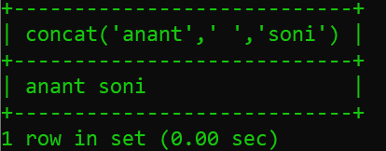

**mysql> select concat(FNAME,LNAME,' ',AGE) from students;**

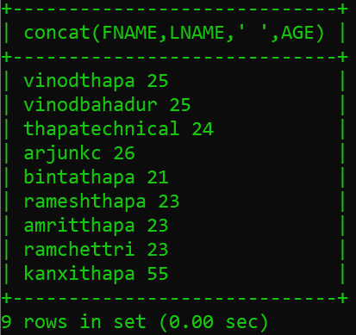

**------- :** **REVERSE FUNCTION : -------**

**mysql> select reverse('thapa');**

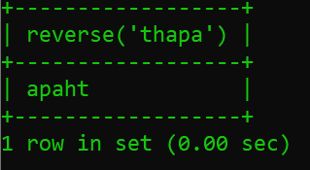

**mysql> select reverse('thapa') as reverse;**

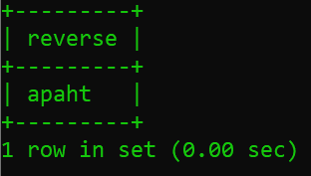

**mysql> select concat ('thapa',reverse('thapa')) as palindrome;**

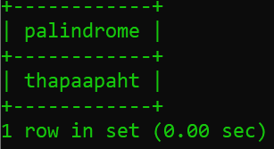

**mysql> select concat ('thapa',' ',reverse('thapa')) as palindrome;**

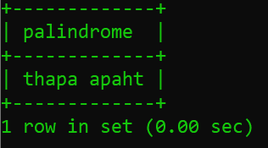

**------- :** **CHAR_LENGTH : -------**

**mysql> select char_length('sonianantrajeshkumar');**

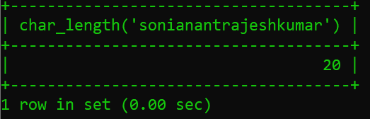

**mysql> select char_length('soni anant rajeshkumar');**

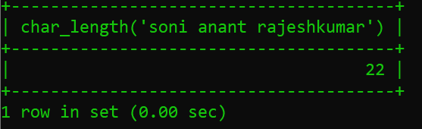

**------- :** **DATE TIME DATA TYPES : -------**

**mysql> create table datestudents(NAME varchar(55),DOB date,DOT time,BD datetime);**

Query OK, 0 rows affected (0.03 sec)

**mysql> insert into datestudents values('vinod','1994-01-05','05:25:45','1994-01-05 05:25:45');**

Query OK, 1 row affected (0.01 sec)

**mysql> insert into datestudents values('anant','2004-07-10','01:07:17','2004-07-10 01:07:17');**

Query OK, 1 row affected (0.01 sec)

**mysql> select*from datestudents;**

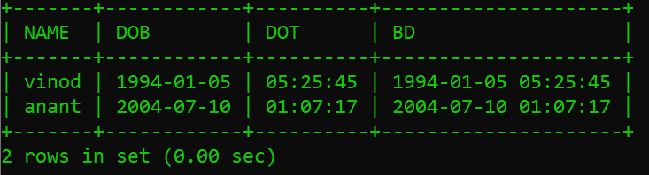

**mysql> insert into datestudents values('vinod',curdate(),curtime(),now());**

Query OK, 1 row affected (0.01 sec)

**mysql> select*from datestudents;**

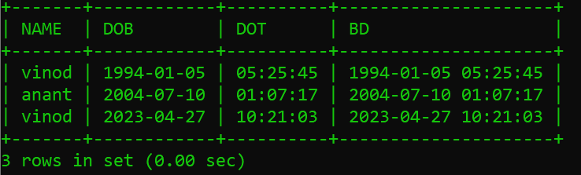

**mysql> insert into datestudents values('dhruv',curdate(),curtime(),now());**

Query OK, 1 row affected (0.01 sec)

**mysql> select*from datestudents;**

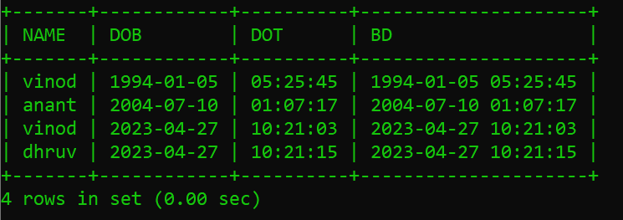

**------- :** **FOREIGN KEY : -------**

**mysql> create table customers(CID int not null auto_increment primary key,CNAME varchar(55),EMAIL varchar(100));**

Query OK, 0 rows affected (0.03 sec)

**mysql> create table orders(OID int not null auto_increment primary key,ODATE date,CID int,foreign key(CID) references customers(CID));**

Query OK, 0 rows affected (0.04 sec)

**mysql> desc customers;**

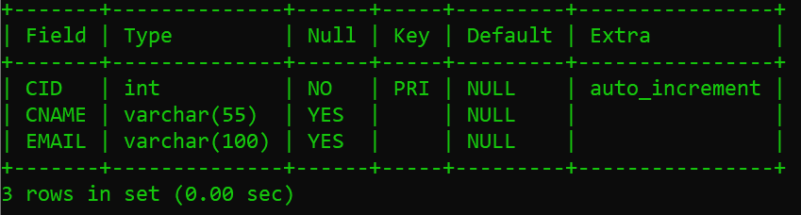

**mysql> desc orders;**

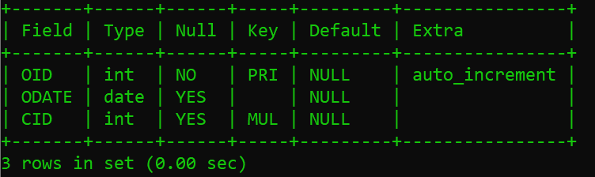

**mysql> insert into customers values(1,'anant','anant204@gmail.com');**

Query OK, 1 row affected (0.01 sec)

**mysql> insert into customers values(2,'dhruv','dhruv565@gmail.com');**

Query OK, 1 row affected (0.01 sec)

**mysql> insert into customers values(3,'kenil','kenil585@gmail.com');**

Query OK, 1 row affected (0.01 sec)

**mysql> select*from customers;**

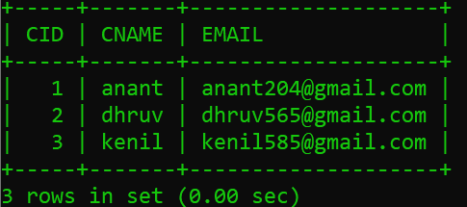

**mysql> insert into orders values(1,'2019/05/05',1);**

Query OK, 1 row affected (0.01 sec)

**mysql> insert into orders values(2,'2020/08/04',2);**

Query OK, 1 row affected (0.00 sec)

**mysql> insert into orders values(3,'2021/04/08',3);**

Query OK, 1 row affected (0.00 sec)

**mysql> alter table orders add amount int;**

Query OK, 0 rows affected (0.03 sec)

Records: 0 Duplicates: 0 Warnings: 0

**mysql> select*from orders;**

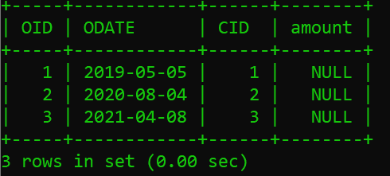

**mysql> update orders set amount=250 where OID=1;**

Query OK, 1 row affected (0.01 sec)

Rows matched: 1 Changed: 1 Warnings: 0

**mysql> update orders set amount=350 where OID=2;**

Query OK, 1 row affected (0.01 sec)

Rows matched: 1 Changed: 1 Warnings: 0

**mysql> update orders set amount=450 where OID=3;**

Query OK, 1 row affected (0.01 sec)

Rows matched: 1 Changed: 1 Warnings: 0

**mysql> select*from orders;**

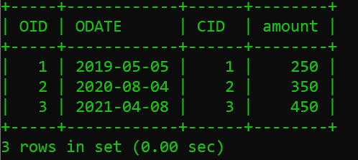

**------- :** **SQL JOIN : -------**

**------- :** **INNER JOIN : -------**

**mysql> select*from customers,orders where customers.CID=orders.CID order by ODATE;**

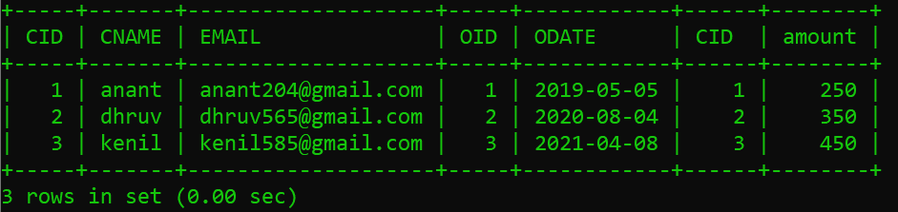

**mysql> select CNAME,EMAIL,ODATE from customers inner join orders on customers.CID=orders.OID;**

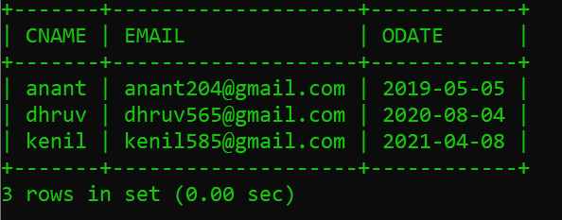

**mysql> select CNAME,EMAIL,ODATE,amount from customers inner join orders on customers.CID=orders.OID;**

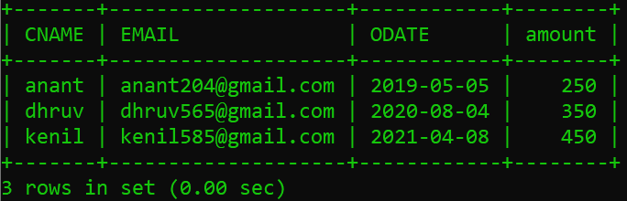

**------- : Column 'CID' in fields list is ambigues : ----------**

**mysql> select CNAME,ODATE,amount,CID from customers join orders on customers.CID=orders.CID;**

**ERROR 1052 (23000): Column 'CID' in field list is ambiguous**

**ERROR : - { BEACUSE 2 FIELDS LIST 'CID' IN TABLE }**



**mysql> select CNAME,ODATE,amount,customers.CID from customers join orders on customers.CID=orders.CID;**

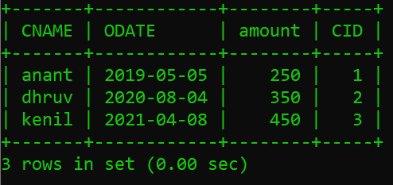

**------- :** **LEFT JOIN : -------**

**mysql> insert into customers values(5,'het','het209@gmail.com');**

Query OK, 1 row affected (0.01 sec)

**mysql> select*from customers;**

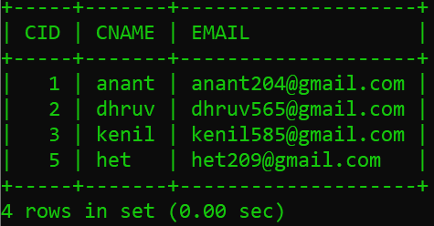

**mysql> select*from customers left join orders on customers.CID=orders.CID;**

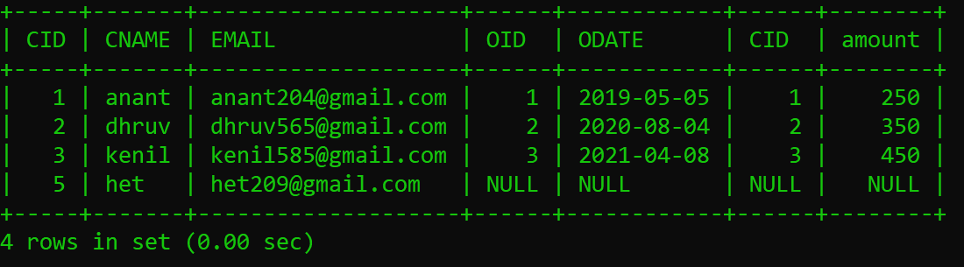

**------- :** **RIGHT JOIN : -------**

**mysql> select*from customers right join orders on customers.CID=orders.CID;**

